Home Page: <https://www.angel-jobs.mt/>

Correction-1

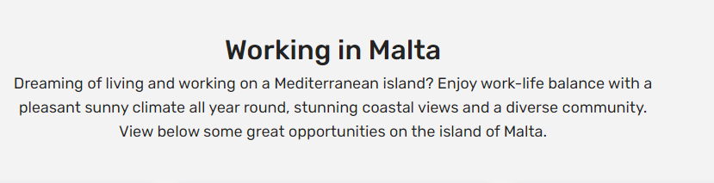

Imagine living and working on a beautiful Mediterranean island! Experience a perfect balance between work and life, surrounded by sunny weather, breathtaking coastal scenery, and a diverse community. Discover skill-match job opportunities on the island of Malta below.

Correction-2:

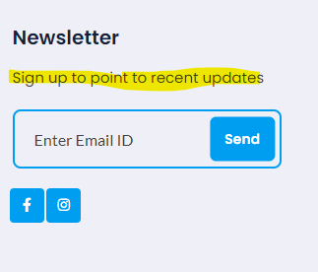

Replace highlighted line:

**Sign up for the latest news updates.**

Page URL: <https://www.angel-jobs.mt/security-center>

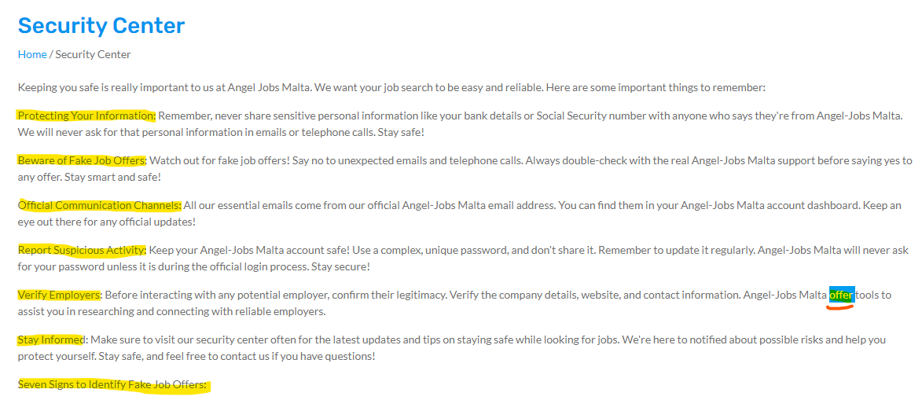

All highlighted heading must be in Bold and add s to the end of offer: like - **offers**